***LAKME 222***

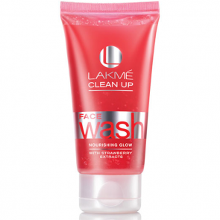

***DESCRIPTION:***

**LAKME’S CLEAN UP DAILY FACE WASH IS 100% SOAP FREE AND MILK BALANCED.ENRICHED WITH VITAMIN-E.IT GENTLY CLEANSES AND MOISTURIZES YOUR SKIN,KEEPING IT SOFT,HEALTHY AND GLOWING.SOAP WITH ITS ALKALINE PROPERTIES REMOVES ESSENTIAL OILS FROM YOUR SKIN LEAVING IT DRY AND FLAKY.**